

ASSIGNMENT REPORT

|  |  |  |
| --- | --- | --- |
| COURSE CODE | : | BTPR2053 |
| COURSE | : | Fundamental Of Image Processing |
| SEMESTER & YEAR | : | Semester 1 2020 |
| INSTRUCTOR | : | Pang Yee Yong |

|  |  |  |
| --- | --- | --- |
| Nama | Student ID | Batch |
| Wong Yik Mun | B180304C | BoSE18-C2 |

**Assignment 1**

Input: yoda.tif

Output:

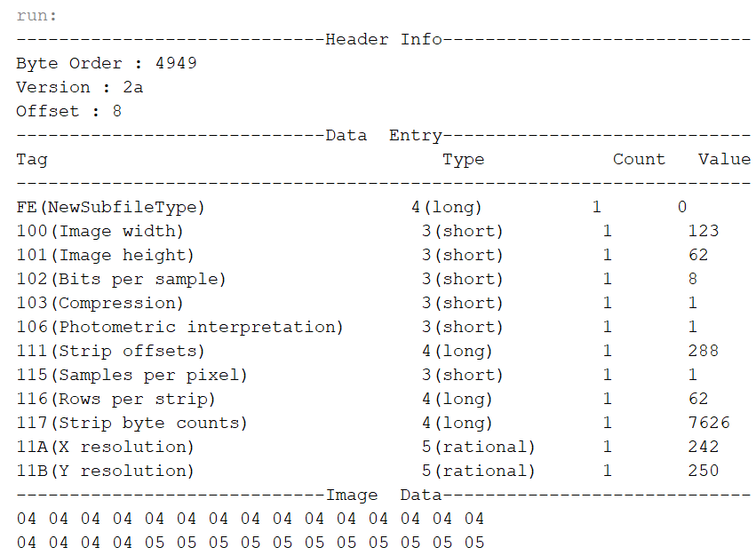

**Assignment 2**

Input:

Output:

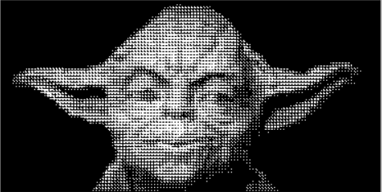



Yoda.raw (Original Image) yoda_pattern.raw

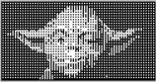 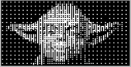

yoda_D1.raw (2X2) yoda_D2.raw (4X4)

**Assignment 3**

Input:

Output:

Yoda.raw (Original Image)

Yoda_his.raw

**Assignment 4**

Input:

Output:

Yoda.raw (Original Image)

yoda _convolution.raw

**Assignment 5**

Input:

Output:

yoda.raw (Original Image)

yoda _low.raw (Low Pass Filter) yoda_high.raw (High Pass Filter)